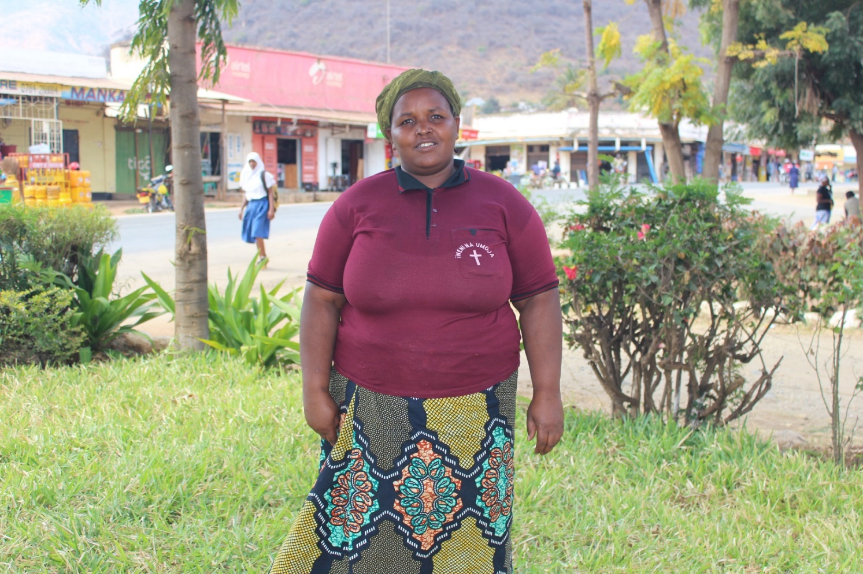
This is Jane. She is a member of a MU Vicoba in Mpwapwa diocese, Tanzania. Jane has her own business, running a small cafe from her rented home near where this photo was taken. Making regular savings through her Vicoba has enabled Jane to expand her business in a way she did not think was possible before. God has taken Jane’s small savings and faithful effort and blessed it for the benefit of her family, the fellowship of her MU group. Therefore, she has been able to open a restaurant in her hotel so that she can provide food for her guests and this has increased her profit.
Jane’s MU Vicoba groups has given her fresh hope for the future. Through the fellowship and hard work of her MU Vicoba, Jane and other MU members can dream of buying land to build their own house and provide security for their families.

